

Project Proposal

Skill Development Project I – ICT 1108

Bachelor of Information and Communication Technology (Honors)

Department of Information and Communication Technology
Faculty of Technology
Rajarata University of Sri Lanka

Details of the Project

Project Title
Group Number
Group Name
Submission Date

Details of the Group Members
Name | Registration ID | Index No. | Signature

Details of Supervisor(s)
Name
Designation
Department/ Unit/ Institute
Contact Details

Table of Contents
1. Introduction 4
1.1 Title of the Project 4
1.2 Background of the Project 4
1.3 Purpose and Significance of the Project 4
1.4 Problem Statement 5
1.5 Aims and Objectives 6
1.6 Scope of the Project 6
1.7 Project Methodology 8
1.8 Expected Results and/or Innovations 10
1.9 Project Schedule / Work Plan 11

List of Tables
Right-click this list and choose "Update Field" to generate the entries.
List of Figures
Right-click this list and choose "Update Field" to generate the entries.

1. Introduction

1.1 Title of the Project
EduPulse - “An integrated student Growth, Wellness and Community Tracking System.”

“ A Web-Based Student Activity Tracking System that integrates how university students track their academic and personal growth. Instead of relying on separate, disjointed tracking methods, this tool combines a study analysis, athletic loggers, and university community hub into one space with customized access for students, community admin, and system administrators."

1.2 Background of the Project
The Problem
University life is not just about classes. Students have to manage studies, sports, and club activities. Right now, students use different, scattered tools to manage this, and there is no single platform to plan and track all three together at our university. Because of this, information gets separated, activities are forgotten, and time is poorly managed [1]. Fragmented promotion across social media, messaging apps, and notice boards also means events are often missed, whereas a centralized campus platform has been shown to increase student club engagement [2]. In addition, students cannot easily see whether they keep a good balance between study, health, and community life, even though regular physical activity [3] and a healthy learning–life balance [4] are closely linked to better academic performance and lower stress.
Solution
To solve this problem, we propose EduPulse, a single dashboard web application for students.
- All in one dashboard : Students can view study timetable, sports schedule, and club activities in one place.
- Home Page Reminder : Important tasks, practices and events are shown as reminders on the home page so students don’t miss them.
- Better Work Life Balance : Helps students maintain balance between study, health and other activities.
- Easy Planning : Replaces paper timetables, alarms and WhatsApp groups with one centralized platform.

1.3 Purpose and Significance of the Project
This project aims to build a system that helps students manage study, sports, and club activities in one place.

It helps students:
- Track study time with a manual timer.
- Plan and finish sports activities.
- Join and register for community events.
This system turns all activities into simple charts and reminders so students can easily track their time.

1.4 Problem Statement
Students at the university do not have a single system to manage their studies, sports, and community activities. Study time is not tracked, so students cannot tell which subjects they are neglecting, which makes effective time management difficult [1]. Sports activities are planned informally and are often skipped without any record, even though regular physical activity supports both wellbeing and academic performance [3]. Community event details are scattered across different channels, so students miss deadlines and organizers cannot reach them easily, even though a centralized events platform can markedly improve club participation and campus-wide visibility [2].
The proposed solution is a centralized, user-friendly tracking system that records study, sports, and community tasks in one place for easy access; provides on-screen reminders that help students stay on track and avoid missed deadlines; visualizes progress through dashboards and graphs that show how time is being spent across activities; and delivers role-based access so that each type of user sees only the functions relevant to them, keeping the system simple and focused.
At present, students rely on separate tools that lead to poor time management, missed opportunities, and an unbalanced learning–life routine [1], [4]. EduPulse addresses this by bringing everything into one simple and secure platform where users can plan, track, and receive reminders in real time. In doing so, the system creates balance, helping students manage their responsibilities better and stay organized across academics and activities.

1.5 Aims and Objectives
To develop EduPulse, a web-based integrated system that helps university students plan, record, and visualize their academic, athletic, and community engagements within a single unified platform.
Objectives:
- To track students' study time, focused time, and play time so that they can improve their time management.
- To encourage sports and physical activities by presenting daily and weekly sports time through charts and graphs that motivate students to stay physically active.
- To build social engagement by enabling students to participate in communities, clubs, and associations, and to join events easily.
- To enhance announcements and administrative communication by allowing administrators and community managers to post announcements that students receive instantly.
- To provide planning and calendar management by creating schedules for academics, sports, and events that help students organize their time effectively.
- To analyse performance by visualizing data such as the most-focused subject, the least-focused subject, and weekly study and sports hours using pie charts to help identify areas of weakness.
- To provide motivational feedback by showing inspiring quotes based on students' progress to boost their morale and mental strength.
- To manage user profiles by letting students view, edit, and log out of their profile while ensuring the security of their personal data.
- To implement role-based access by providing appropriate features for each user role — Student, Community Admin, and Admin — to ensure secure and efficient usage.

1.6 Scope of the Project
This project aims to build a web-based student activity management system with well defined user roles, essential features for managing academic, sports, and community activities, and a responsive, secure technical implementation. It is designed to improve time management, organization, and work-life balance for students.

User Roles & Permissions
- Student
- Register, login, and set up profile
- Study module: set focus timer, log study, view charts and subject summary.
- Sports module: schedule activities, log duration, see daily/weekly graphs.
- Community module: join clubs/societies, view events and announcements.
- Dashboard: quick links, weekly summaries, and activity calendar.
- Community Administrator
- Manage community groups: clubs, media units, societies
- Post and manage events and announcements
- System Administrator
Can do everything above, plus:
- Manage all users and accounts
- Control system settings and overall data
System Features
Authentication System
- Role based access control
- Secure registration/login
- Profile Setup

Modules
- Education: study timer, log study, pie charts and weekly graphs
- Sports: schedule activities, log duration, daily/weekly graphs
- Community: join clubs, societies, and view events
Communication Tools
- Join clubs, media units, and societies
- Post and view community events and announcements
Dashboard & Analytics
- Weekly overview
- Shows study hours & graph.
- Shows sports logged hours & graph.
- Shows upcoming joined event counts.
- Calendar View
- Shows all education, sports and community events.
- Click any date to add or remove reminders.

1.7 Project Methodology
1.7.1 Development Approach
The system will be developed using a seven-phase approach, illustrated in Figure 1, to ensure high quality, ease of use, and better performance.
- Requirement Gathering - Identify features, user roles, and system goals.
- UI/UX Design - Create wireframes and design a user-friendly interface.
- Frontend Development - Build the interface using HTML, CSS3, and JavaScript.
- Backend & Database Integration - Use PHP and MySQL to handle logic and data storage.
- Authentication & Role Access – Implement secure login and user roles.
- Testing – Check for errors, fix bugs, and ensure smooth performance of timer, graphs, reminders and modules.
- Documentation – Prepare final reports and usage guides.

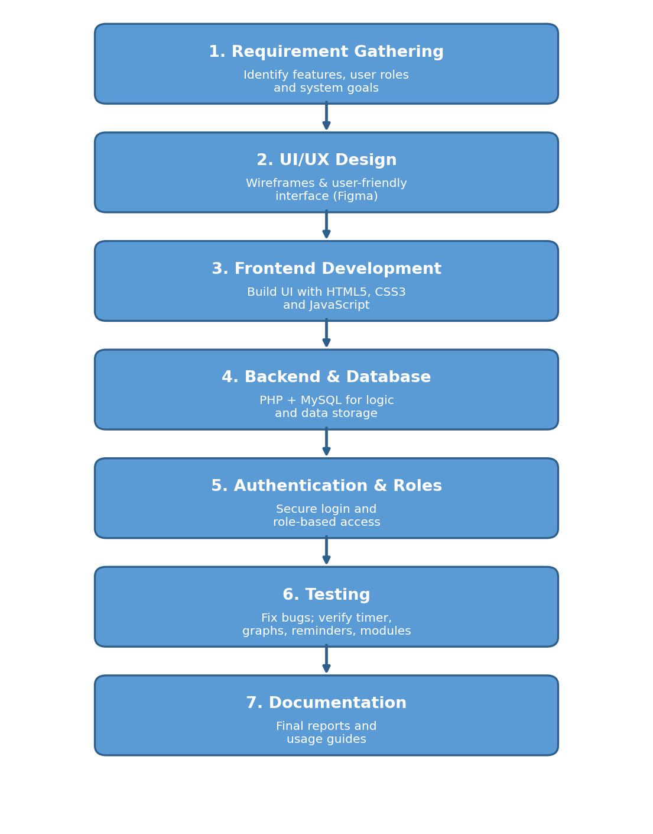
Figure 1: System Development Methodology
1.7.2 Project Design
Figure 2 presents the overall design of the EduPulse system.
Figure 2: EduPulse System Design
1.7.3 Techniques and Tools
Programming Languages:
- HTML5, CSS3, JavaScript for frontend development of the study timer, dashboards, and community hub.
- PHP (procedural) for backend logic and processing of study logs, athletic data, and user management.
Database Technology:
- MySQL will be used as the relational database management system to store users, study records, sports logs, community posts, and status records securely.
Integrated Development Environment (IDE):
- Visual Studio Code (VS Code) will be the primary IDE used for coding, managing files, and debugging both frontend and backend code.
UI/UX Design Tools:
- Figma will be used for wireframing and designing user interfaces for Student, Community Admin, and System Admin dashboards.
Version Control:
- Git & GitHub for code tracking, collaboration, and backup.

Testing Tools:
- Manual Testing for usability and functionality.
- Chrome DevTools for frontend debugging and responsiveness checks.
Server & Hosting:
- PHP + MySQL Hosting for putting the website online.

1.8 Expected Results and/or Innovations
Core Functionality:
- Fully operational web platform with intuitive UI
Easy to use for both students and university admins
- Dual-role access (Student / Admin)
Students can log and track. Admins can view reports and monitor activities
- Study Focus Timer + Activity Loggers
Track study sessions, sports activities, and university/community events in one place
- Personal Progress Dashboard
View study hours, sports records, and participation with charts and graphs
- Real-time analytics and reports
Get instant insights on academic focus, fitness, and extracurricular involvement.
Key Improvements
- All-in-one tracking (vs using separate apps, notes, and paper)
- Digital record-keeping for study, sports, and community activities
- Better time management and self-awareness for students
- Transparent progress tracking for both students and university staff
Future Enhancements

Table 1: Future Enhancements and Benefits
Innovation | Benefits
Study Timer | Gets accurate study duration
Community Helpdesk | Helps to clarify our community doubts

1.9 Project Schedule / Work Plan
The project is planned over the schedule shown in Table 2, which lists each task with its intended start and end dates. The same schedule is illustrated as a Gantt chart in Figure 3.

Table 2: Project Schedule / Work Plan
Activity | Start Date | End Date | Milestone
Requirement Analysis | 19/06/2026 | 26/06/2026 | Requirements finalized
Feasibility & Literature Review | 19/06/2026 | 30/06/2026 | Literature review completed
System Design | 27/06/2026 | 07/07/2026 | System architecture completed
Database Design | 08/07/2026 | 15/07/2026 | Database schema finalized
Frontend Development | 16/07/2026 | 29/07/2026 | UI modules completed
Backend Development | 23/07/2026 | 06/08/2026 | Backend functionalities completed
System Integration | 07/08/2026 | 11/08/2026 | Integrated system ready
Testing & Debugging | 12/08/2026 | 14/08/2026 | Error-free system
User Feedback & Improvements | 15/08/2026 | 16/08/2026 | System refined
Documentation | 16/08/2026 | 17/08/2026 | Final report completed
Final Review & Presentation | 18/08/2026 | 18/08/2026 | Project submission
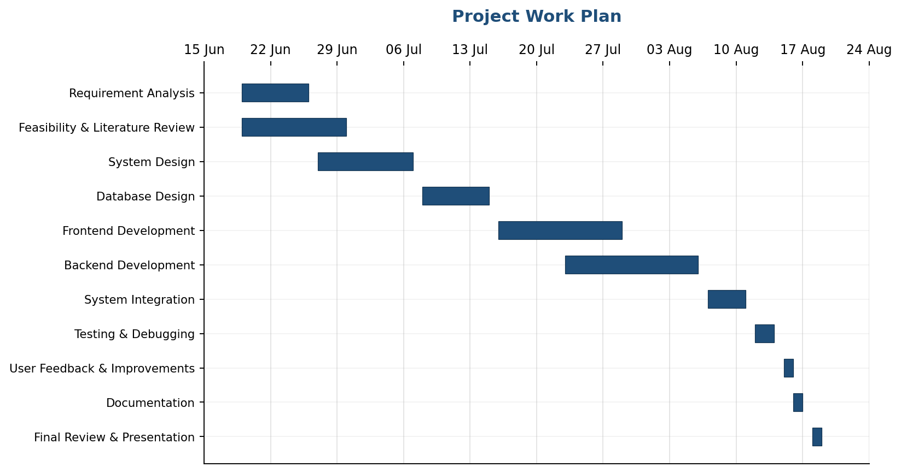
Figure 3: EduPulse Project Work Plan (Gantt Chart)

References
[1] R. V. Adams and E. Blair, “Impact of time management behaviors on undergraduate engineering students’ performance,” SAGE Open, vol. 9, no. 1, 2019, doi: 10.1177/2158244018824506.
[2] Concept3D, “How universities can increase student club engagement with a centralized events platform,” Concept3D Blog. [Online]. Available: https://concept3d.com/blog/event-calendar/how-universities-can-increase-student-club-engagement-centralized-events-platform/ (accessed Jul. 18, 2026).
[3] “Strategies and best practices that enhance the physical activity levels of undergraduate university students: A systematic review,” International Journal of Environmental Research and Public Health, vol. 21, no. 2, Art. no. 173, 2024, doi: 10.3390/ijerph21020173. [Online]. Available: https://pmc.ncbi.nlm.nih.gov/articles/PMC10888190/
[4] K. Szegedi, Z. Győri, and T. Juhász, “Factors affecting quality of life and learning-life balance of university students in business higher education,” Humanities and Social Sciences Communications, vol. 11, Art. no. 113, 2024, doi: 10.1057/s41599-024-02603-7.
2. Recommendation of Supervisor on the Problem and Project Proposal (This section should be filled by the supervisor(s). Supervisor(s) may consider the adequacy and scope of the problem, quality and adequacy of the background study, methodology proposed, and the schedule).
Comments (if any):

I certify that, the student engaged continuously with me in developing the proposal and, I am confident that he is adequately competent to defend this proposal.

……………………………

Signature of Supervisor
Date: ………………………

3. Project Proposal Defense Assessment Team (this section should be filled by the department)
Date of project proposal defense:
Panel Members | Name | Department / Institute
Chair
Member
Member
Member
Member

Comments of the Assessment Team on the Project Proposal (This should be filled by the chair of the assessment panel. In case of revision or fail, needed revision in the proposal or reasons to fail the proposal should be mentioned here)
Result of the project proposal | Excellent / Good / Pass with revisions / Fail
Score
Signature of the panel chair
Date

